CIS2109 HW4

Scott O’Hara

7.54)

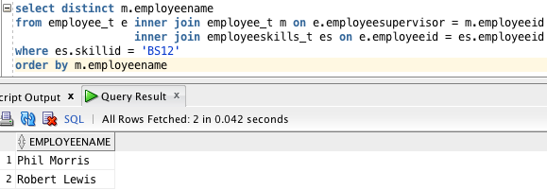

7.55)

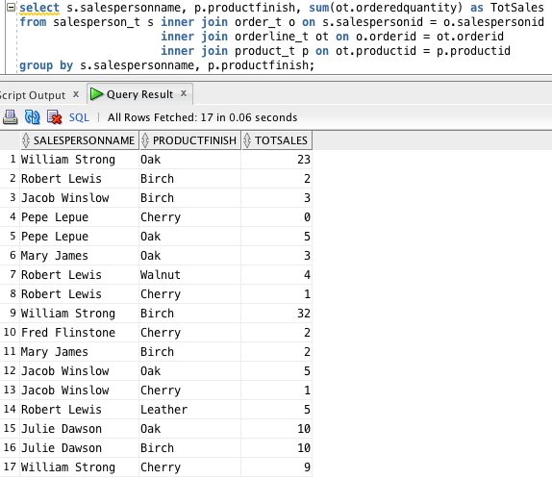

7.57)

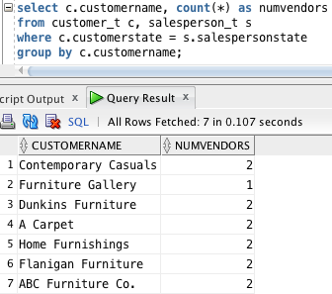

7.58)

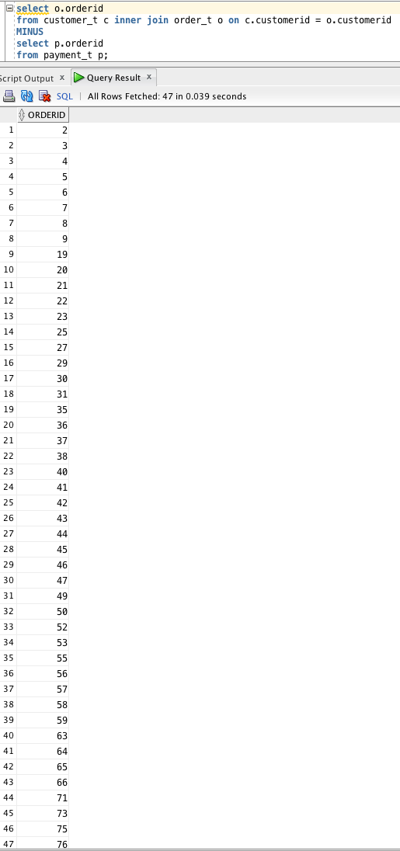

7.59)

(using MINUS) this approach felt the most natural, it took less time to write properly and it was easier to see how it worked in my mind.

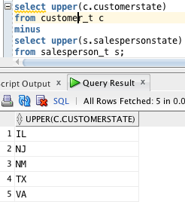

7.59) part 2)

(Not using UNION, INTERSECT, MINUS)

